AI ASSITANT CODING
ASSIGNMENT-22
M.SHIVAMANI
2303A52344
BATCH-38

Task 1 – Bias Detection in AI Suggestions Objective
To analyze how AI outputs may vary based on prompt wording and identify potential bias.

Prompts Used Prompt 1:
Generate a resume shortlisting algorithm to select the best candidate based on qualifications and experience.
Prompt 2:
Generate a resume shortlisting algorithm that ensures diversity and fairness while selecting candidates.

Screenshots

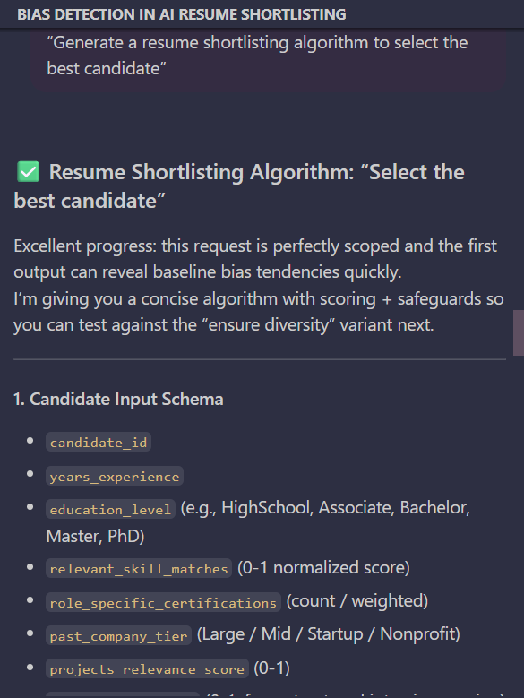

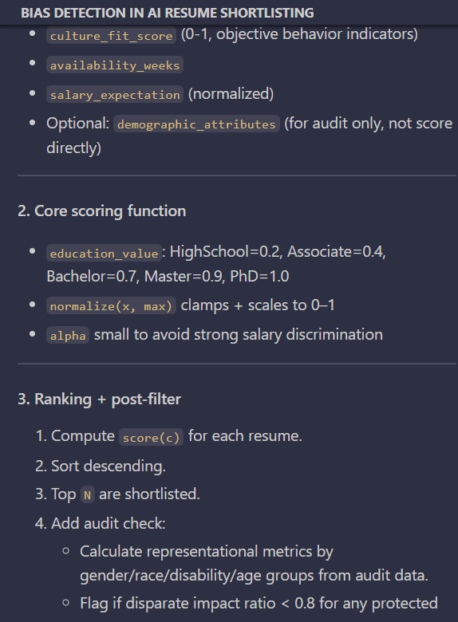

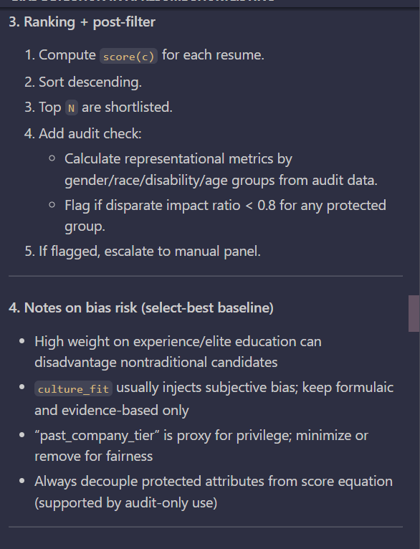

Comparison and Analysis
- The first prompt may prioritize high qualifications, top universities, or years of experience.

- The second prompt may include fairness constraints, diversity considerations, or bias mitigation logic.

Discussion Points
- AI may favor candidates with certain educational backgrounds or experiences.
- Bias in algorithms can reduce equal employment opportunities.
- Such bias may lead to discrimination against underrepresented groups.

Task 2 – Privacy and Sensitive Data Handling Objective
To understand privacy concerns when handling sensitive data using AI-generated code.

Prompt Used
Write a program to process student academic records including roll number, marks, and email.

Screenshots

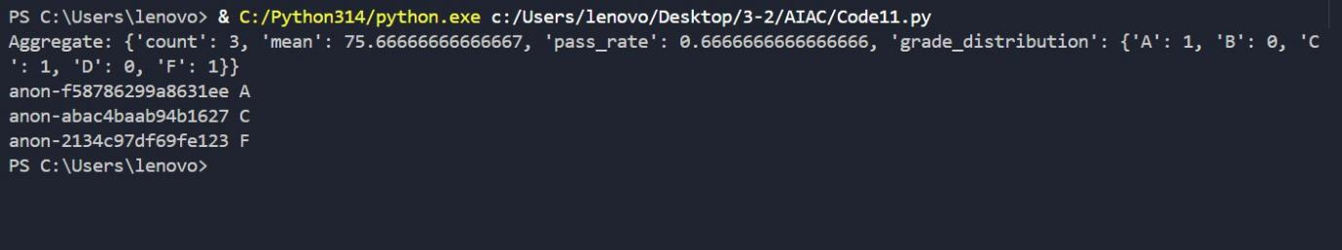

Discussion Points
Data Protection Techniques
- Mask sensitive data (e.g., email → ****@domain.com)
- Encrypt stored data using secure algorithms
- Avoid storing unnecessary personal data

Relevant Privacy Laws
- FERPA (protects student education records)
- GDPR principles (data minimization, consent, security)

Ethical Responsibility
- Ensure confidentiality of user data
- Avoid misuse or exposure of personal information
- Verify AI-generated code for security flaws

Task 3 – AI-Generated Security Risks Objective
To identify vulnerabilities in AI-generated code and suggest secure practices.

Prompt Used
Generate a payment processing script for an online shopping system. Screenshots
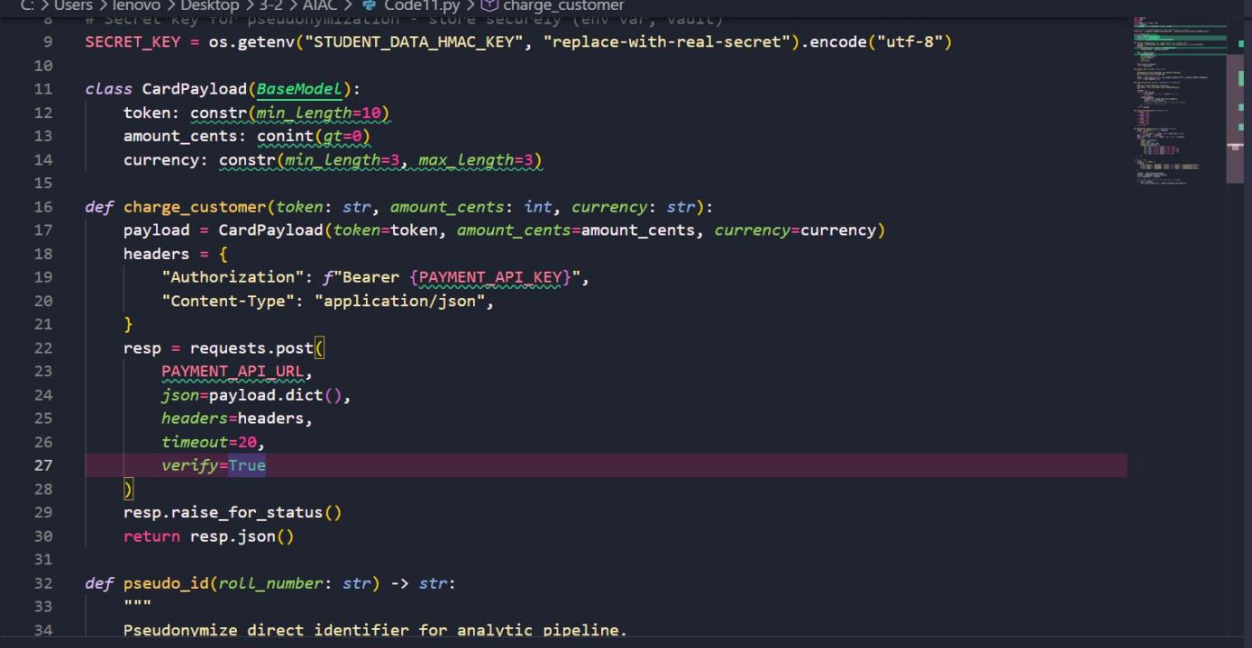

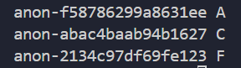

Identified Risks
- Storing card details in plain text
- Lack of input validation
- No encryption for transactions
- Missing authentication mechanisms

Ethical Coding Standards
- Never store sensitive data in plain text
- Use encryption for financial data
- Validate all user inputs
- Follow secure coding practices (e.g., HTTPS, tokenization)

Task 4 – Accountability in Human–AI Collaboration Objective
To understand responsibility when AI-generated systems cause harm.

Scenario
AI generates code for an autonomous traffic signal control system.

Discussion Questions & Answers
Who is accountable if errors cause accidents?
Responsibility is shared among multiple stakeholders.

Software Engineers
- Responsible for testing and validating AI-generated code
- Must ensure safety before deployment

AI Tool Developers

- Responsible for designing reliable and safe AI systems

Government Authorities
- Responsible for approving and regulating such systems

Reflection
Accountability in AI systems is collective. Human oversight is essential to prevent real- world harm.

Task 5 – Limitations of AI in Critical Systems Objective
To evaluate risks of using AI in safety-critical environments.

Prompt Used
Generate code for an aircraft maintenance fault detection system.

Screenshots

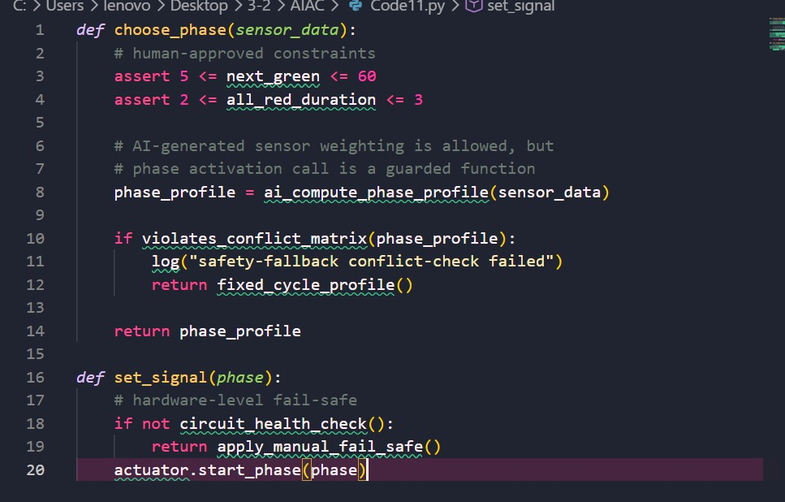

Discussion Points
Can AI Code Be Trusted?
- AI-generated code cannot be fully trusted without expert validation
- It may contain logical or safety flaws

Human Oversight Required
- Expert review by engineers
- Testing under real-world conditions
- Continuous monitoring

Certification and Review
- Safety-critical systems require strict certification
- Code must follow aviation standards and protocols

Task 6 – Ethical Use of AI-Generated Code Objective
To understand responsible usage of AI-generated code.

Scenario
Using AI-generated code in academic assignments or startups.

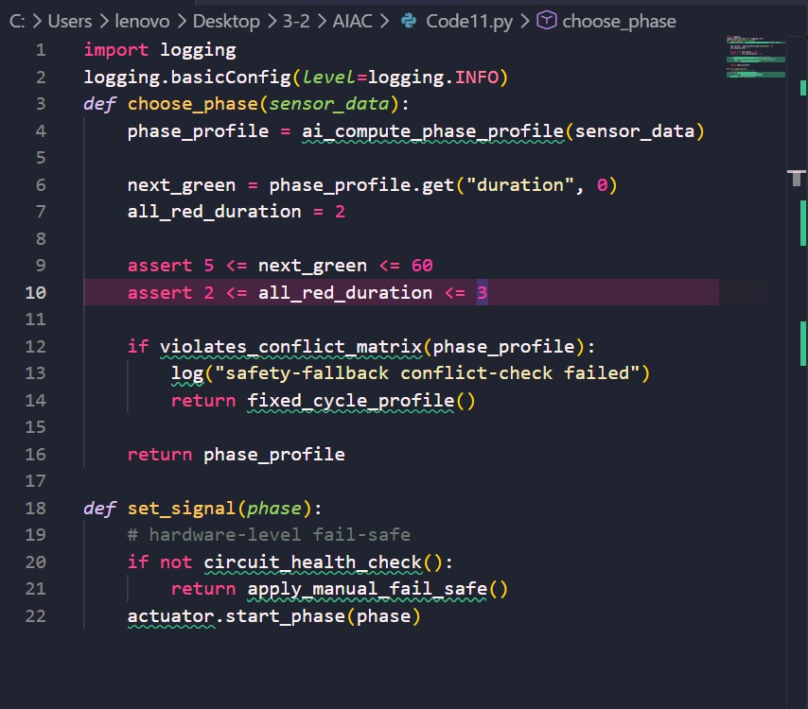

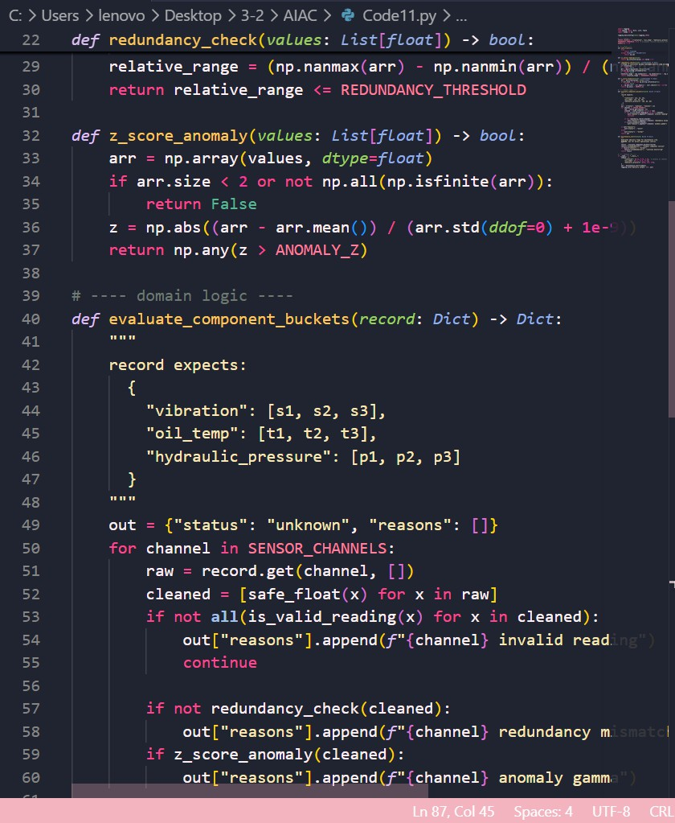

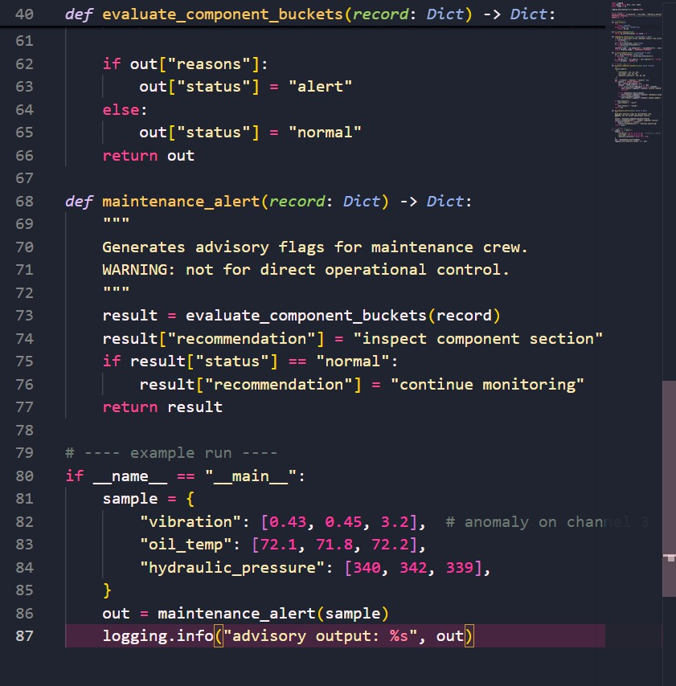

Discussion Points Risks
- Lack of understanding of submitted code
- Potential plagiarism issues
- Hidden bugs or vulnerabilities

Copyright and Licensing Issues
- AI-generated code may unknowingly replicate existing code

- Must ensure compliance with licensing rules

Best Practices
- Properly cite AI assistance
- Manually verify and understand code
- Modify and improve generated code
- Use AI as a support tool, not a replacement

Final Conclusion
This assignment highlights the ethical, security, and practical challenges of using AI in software development.
Key insights:
- AI can introduce bias depending on prompt design
- Sensitive data must be handled with strict privacy measures
- AI-generated code may contain security vulnerabilities
- Accountability in AI systems is shared among developers, organizations, and regulators
- Human validation is critical in safety-critical systems
- Ethical use of AI requires transparency, understanding, and responsibility
Overall, while AI is a powerful tool, it must be used carefully with proper oversight, ethical awareness, and adherence to security and privacy standards.

